Development, Planning and Trees
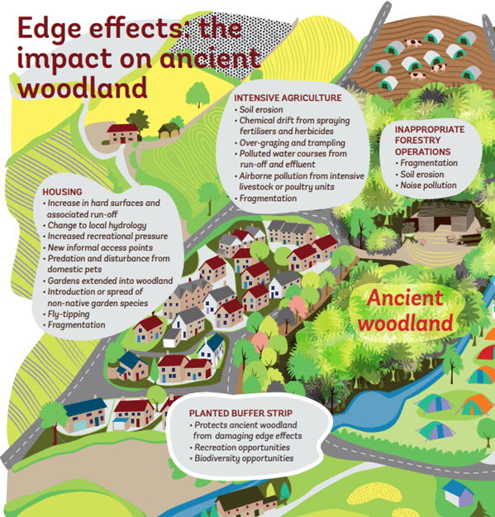
Development does not only lead to the loss of ancient woodland and veteran trees it directly displaces. In many cases it can also harm adjacent woods, which may be spared the bulldozer and the saw, but nonetheless suffer a slow decline in ecological condition over time. This effect of development is often overlooked. Declines in ecological condition happens over extended periods of time and this is perhaps why people find it hard to understand. It’s not an immediately quantifiable loss and due to the long-life cycles of trees it’s not at once visible. Our baselines shift, and we forget how these woodlands once looked and felt, but gradually they decline and slowly quieten, until finally they disappear.
But well-devised planning can protect trees from inappropriate development. Whether that’s high-level protections outlined by Scottish government or developers integrating buffer strips and root protection zones into their development designs.
However, protections outlined to date by the government have been insufficient to protect ancient woodland and ancient and veteran trees. Whilst planning policy highlights the irreplaceable nature of these habitats, as of July 2020 the Woodland Trust was aware of 274 ancient woodlands threatened by development. The real figure is likely higher.
Development is not the biggest threat to ancient woodland in Scotland. Pressure from deer is a much deeper-rooted issue. Results from the Native Woodland Survey for Scotland (NWSS) reported ancient woodland cover had reduced by ~21,044ha between the recording of the Ancient Woodland Inventory (AWI) and the recording of the NWSS. Roughly 90% of that loss was most likely due to herbivore pressures in combination with the poor regeneration capacity of older trees.
Development can fragment habitats changing the climatic conditions inside them, so altering the species suited to live there. A new housing development may lead to garden waste thrown over the fence into ancient woodland. That waste may contain INNS, those may spread through the site damaging its ecological condition.
The multitude of threats present is leading to the decline of woodlands across the country. We are facing the very real fact that 97% of native woodlands are in poor ecological condition and less than 2% of Scotland is now covered by ancient woodland.

